Walmart Business Problems

# Analyze Payment Methods and Sales

* + **Question:** What are the different payment methods, and how many transactions and items were sold with each method?
  + **Purpose:** This helps understand customer preferences for payment methods, aiding in payment optimization strategies.
  + **Code:**

SELECT

payment_method,

COUNT(*) AS no_payments,

SUM(quantity) AS no_qty_sold

FROM walmart_clean_data

GROUP BY payment_method;

# Identify the Highest-Rated Category in Each Branch

* + **Question:** Which category received the highest average rating in each branch?
  + **Purpose:** This allows Walmart to recognize and promote popular categories in specific branches, enhancing customer satisfaction and branch-specific marketing.
  + **Code:**

select * from

( select

branch,category,

avg(rating) as avg_rating,

rank() over(partition by branch order by avg(rating)desc) as rank_rating

from walmart_clean_data

group by branch,category

) as ranked

where rank_rating =1;

# Determine the Busiest Day for Each Branch

* + **Question:** What is the busiest day of the week for each branch based on transaction volume?
  + **Purpose:** This insight helps in optimizing staffing and inventory management to accommodate peak days.
  + **Code:**

select *

from

(select

branch,

dayname(str_to_date(date,'%d-%m-%y')) as day_name,

count(*) as no_transactions,

rank() over(partition by branch order by count(*) desc) as rank_transaction

from walmart_clean_data

group by branch,day_name

)as ranked

where rank_transaction=1;

# Calculate Total Quantity Sold by Payment Method

* + **Question:** How many items were sold through each payment method?
  + **Purpose:** This helps Walmart track sales volume by payment type, providing insights into customer purchasing habits.
  + **Code:**

SELECT

payment_method,

SUM(quantity) AS no_qty_sold

FROM walmart_clean_data

GROUP BY payment_method;

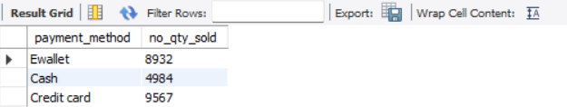

# Analyze Category Ratings by City

* + **Question:** What are the average, minimum, and maximum ratings for each category in each city?
  + **Purpose:** This data can guide city-level promotions, allowing Walmart to address regional preferences and improve customer experiences.
  + **Code:**

select

city,

category,

min(rating) as min_rating,

max(rating) as max_rating,

avg(rating) as avg_rating

from walmart_clean_data

group by city,category;

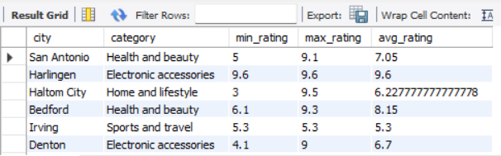

# Calculate Total Profit by Category

* + **Question:** What is the total profit for each category, ranked from highest to lowest?
  + **Purpose:** Identifying high-profit categories helps focus efforts on expanding these products or managing pricing strategies effectively.
  + **Code:**

select

category,

sum(unit_price*quantity*profit_margin) as total_profit

from walmart_clean_data

group by category

order by total_profit desc;

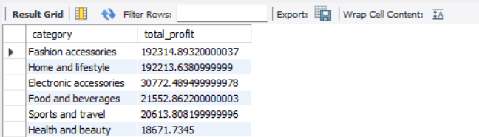

# Determine the Most Common Payment Method per Branch

* + **Question:** What is the most frequently used payment method in each branch?
  + **Purpose:** This information aids in understanding branch-specific payment preferences, potentially allowing branches to streamline their payment processing systems.
  + **Code:**

with cte as

(SELECT

branch,

payment_method,

COUNT(*) AS total_trans,

RANK() OVER(PARTITION BY branch ORDER BY COUNT(*) DESC) AS rank_trans

FROM walmart_clean_data

GROUP BY branch, payment_method

)

select * from cte where rank_trans=1;

# Analyze Sales Shifts Throughout the Day

* + **Question:** How many transactions occur in each shift (Morning, Afternoon, Evening) across branches?
  + **Purpose:** This insight helps in managing staff shifts and stock replenishment schedules, especially during high-sales periods.
  + **Code:**

select

branch,

case

when hour(time(time))<12 then 'Morning'

when hour(time(time))between 12 and 17 then 'Afternoon'

else 'Evening'

end as shift,

count(*) as num_invoices

from walmart_clean_data

GROUP BY branch, shift

ORDER BY branch, num_invoices DESC;

